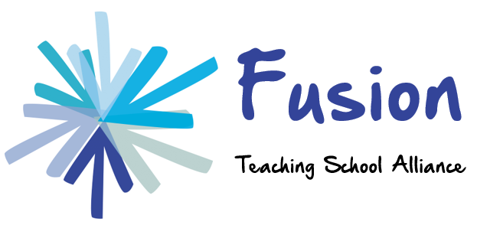

Just a few of the courses/training we could provide you with. We run these across the localities for individual schools, families of schools and MATs.
Emotional Regulation half day workshops.
Sensory circuit workshops.
Essential Autism courses.
Working Memory- teaching strategies to support short term working memory.
Developing partnerships in mathematics and SEND workshops
Introduction workshop to sharing good practice using Shape Coding.
Introduction to SEND- 6 half day workshops.
ASD children Key Stage 2 SAT’s inference skills.
Reducing anxiety levels and possible self-harming.
Strategies for TA’s to support of different SEN needs- Week 1: SEN code, week 2: ASD, week 3: communication, week 4: behaviour, week 5: work shadowing in an SEN school and week 6: Review.
SENCO training.
Governor training.
Introduction to friendship groups- Lego groups, Group Play etc
Positive Behaviour management including de-escalation.
Promoting Mental Health and Wellbeing in the Classroom and beyond.
An Introduction to Nurture, attachment and Nurture Groups.
Introduction to Dyscalculia, Dyslexia, Working Memory, social stories, 5 point scale etc
SEND review training and completing SEND reviews.
Creating Dyslexia friendly classrooms and schools.
Fusion TSA, Talbot Specialist School, Lees Hall Road, Sheffield, S8 9JP
Tel: 0114 2509756 email: cherylgaughan@fusiontsa.co.uk

